**F.1) Test Results for Communication Subsystem**

The data obtained in the measurements are plotted as in Figure **WER.** In the graph, it can be seen that the error rate for laboratory light and dark conditions are pretty close to each other until 15 cm. However, after that point, the difference between them grows largely. According to these test results, we are planning to operate the vehicle in the range of 5-15 cm. This way, we can obtain a system which is more robust to the changing light conditions.

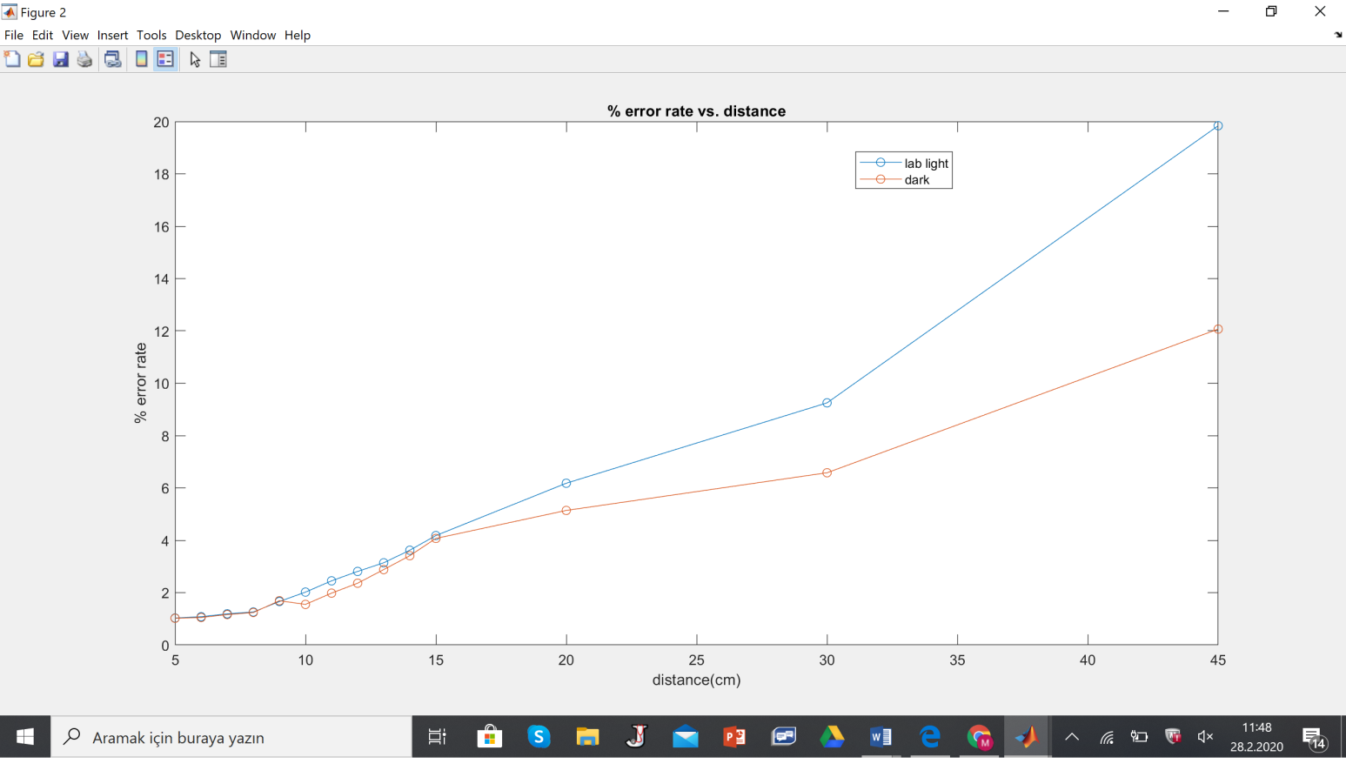

*Figure* ***WER:*** *The bit error rate graph of the test results with respect to the distance*

The requirements which are discussed in the beginning of this report regarding “Gimme Fast” project and related with the communication subsystem are listed and the results of the conducted tests are related with them in the following paragraphs.

1. *a. Some portion of the photo must be transmitted to the vehicle by VLC (Visible Light Communication). (functional requirement)*
2. *b. The data packets carried by the vehicle needs to be delivered to the receiver terminal. (functional requirement)*

In the conducted tests, a photo is not transmitted but a 1024 bit message signal is successfully transferred from transmitter part to receiver part.

1. *c. A minimum DTR (data transfer rate) of 13 kbps will be achieved. (performance requirement)*

In the conducted tests, data transfer rate was 19200 baud which is equal to 15 kbps. Therefore, we can safely say that the communication subsystem meets the speed requirement.

*d. The minimum accuracy rate of 90% should be achieved for the reconstructed image. (performance requirement)*

In the conducted tests, no picture was reconstructed but considering the percentage error at the received data, communication system was successful at all light conditions at a distance varying from 5 cm to 15 cm.